Website Testing: 20/01/2023

**Feature implemented by**: Saahil Shah (ss2357)

**Feature tested by** : Tope Balogun (tb520)

Functionality Testing: (Errors Fixed)

Registration

* Entering name, email, password, confirm password, gender, security question, security answer.
* Dropdown menu for security question and gender
* Password requirements dialogue: it displays but when typing the password, it does not tick off the requirements that are satisfied Fixed by adding JS func() so now when password is being typed, any requirement that is satisfied will appear in green colour.

* Show password feature for password and confirm password: eye icon displays but when clicked on, the password does not appear in text Fixed by adding an event listener, which when clicked on, it changes the “type” field from password to text and vice versa

* “Login instead?” button works fine and once clicked, it takes you to the login page
* “Complete Registration” button: when clicked on it gives an error instead of adding user to the database Fixed by adding php code that adds that user to the database table and if it is done successfully, user receives a popup message saying the user has been registered.

* All fields are required, and form should not submit if a field is empty: Works fine, if a field is left empty and the “complete registration!” button is clicked, form will not submit, and an error message is shown.

* Cannot register the same user twice: not working as the database contains multiple entries of the same person. Fixed by creating a query that displayes all the records that have the same name and email as that inputted in the form, and if it displays 1 or more results, then an error message is shown

* Password and confirm password field should match: works fine and gives an error message when they are not the same

* 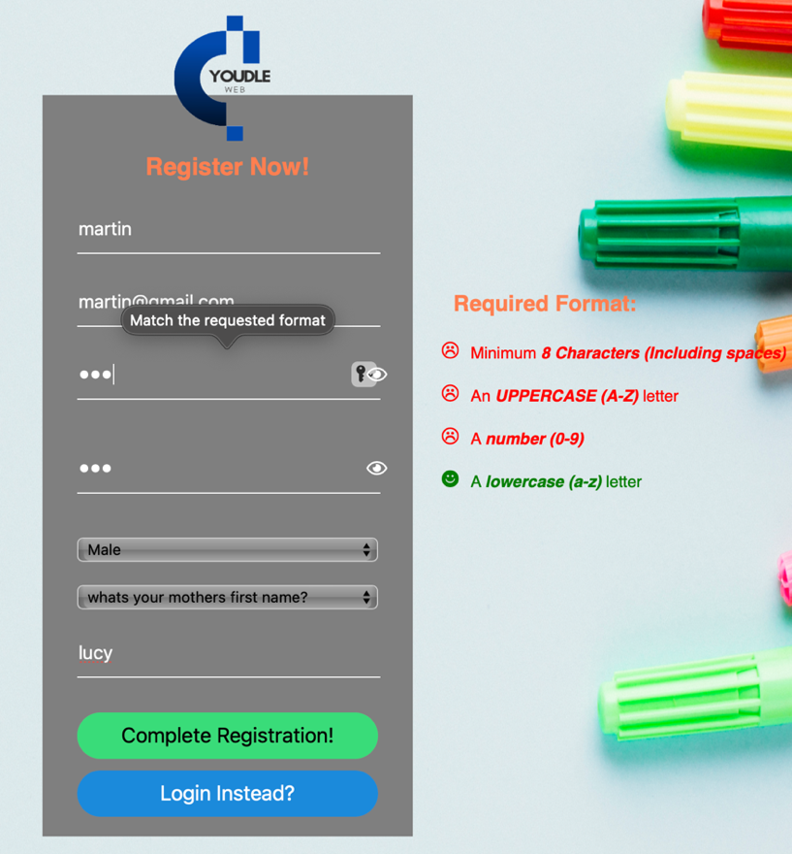Email and password must follow a specific format for the form to be submitted: works fine , error message shown when the password and email address don’t match the requested format. Graphical user interface, application

  Description automatically generated